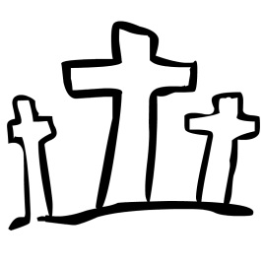
“Why do you look for the living among the dead?
He is not here. He has risen!”
Luke 24

18th March 2016

Dear parents,

We've almost finished another term! I trust you will all have a lovely Easter break with family and friends.

Our last day of school is Tuesday 22nd March and school will close at 12.00pm for all pupils. Our first day back to school in the summer term is Monday 4th April.

Sport Relief Non-Uniform Day
We’d like to support the work of sport relief by holding a ‘RED’ non-uniform day on the last day of term. The children just need to wear as much red clothing as they can, and bring a small donation towards Sport Relief. The children will have the opportunity to play a few games with Stephen Beattie from Tetsu Judo on Tuesday, so please bear that in mind when you are choosing the clothing.

World War II exhibition

The P6/7 class have been studying World War II as their topic this term. As part of this, each child has created a model air-raid shelter as a home project. We have been amazed by the children’s efforts and we'd love you all to have the opportunity to see this wonderful work. We plan to set up the assembly hall as an exhibition this Monday 21st March. Parents and friends are very welcome to come in to view the exhibition at 2.00pm pickup time and again at 3.00pm. There might even be a cup of tea…

School Milk

The cost of school milk for the summer term is £11.00. Please send this to the school office no later than Friday 8th April.

Yours sincerely,

M Beattie
Principal

