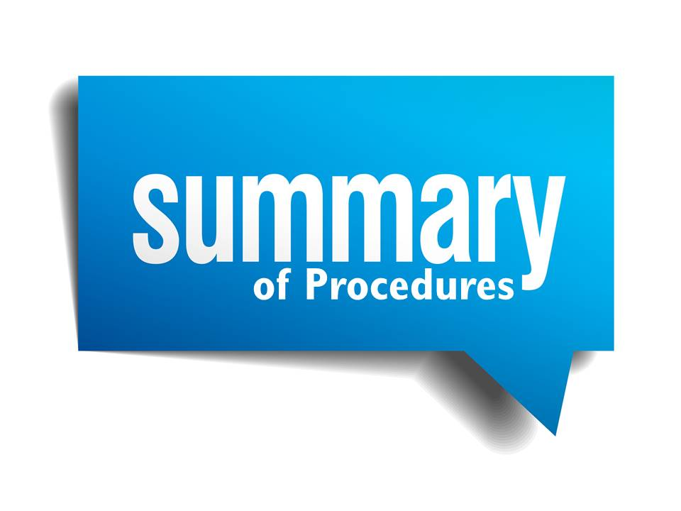
At The Diamond Primary School we have a primary responsibility for the care, welfare and safety of the pupils in our charge and we will carry out this duty through our Child Protection Policy.

Child Protection Policy

Summary of Procedures
The Diamond Primary School
Updated
November 2018

To be Reviewed
December 2019

We as a staff aim to:-

- Provide a caring, supportive and safe school environment.

- Value all children for their unique talents and abilities.

- Promote positive attitudes towards healthy living.

- Help each child to develop his own individual potential to the full.

All our staff and volunteers have been subject to police checks. Our staff has adopted a code of practice for our behaviour towards pupils, which is set out in the Appendix to this policy statement.

Our main priority at The Diamond Primary School is to protect our pupils by ensuring that all our staff know the procedures to follow if abuse is suspected. The welfare and safety of each child will be our paramount consideration. The problem of child abuse will not be ignored by any staff member.

WHAT IS ABUSE?
Child abuse occurs when a child is neglected, harmed or not provided with proper care. Children may be abused in many settings, in a family, in an institutional or community setting, by those known to them, or more rarely, by a stranger.

ABUSE can take a number of forms - PHYSICAL ABUSE, EMOTIONAL ABUSE, SEXUAL ABUSE, NEGLECT and a child may suffer more than one of them.

A child may be at risk of suffering from one or more types of abuse and abuse may take place on a single occasion or may occur repeatedly over time.

- The Designated teacher for Child Protection is Mrs Henry

- In her absence, the Deputy Designated teacher, Mrs Stewart, will assume responsibility for Child Protection matters.

- Our Child Protection Safeguarding Team is made up of five people. Mr Beattie, Mrs Henry, Mrs Stewart and Chairperson of the Board of Governors, Mrs M McKeown and Designated Member for Child Protection on the Board of Governors ( to be confirmed).

If a child makes a disclosure about abuse or staff members have concerns about a child, prompt action must be taken:

- Report to Designated teacher immediately and make a written record of this discussion.
- No contact with parents.
- No promise of confidentiality can or should ever be given where abuse is alleged.
The Designated Teacher’s role should not be seen as diminishing the role of other staff members (teaching and non-teaching) in being alert to the signs of abuse and being aware of the procedures to be followed, including those in cases where an accusation is made against any members of the school’s staff (teaching and non-teaching)

Details of Child Protection procedures are outlined in the appended flow charts.

A full copy of the school’s Child Protection Policy is available for consultation in the school office.

Procedures where the school has concerns, or has been given information, about possible abuse by someone other than a member of the school’s staff

Keep a written record of complaint at all steps
The complaint is about possible abuse by someone outside the school

Tell the Designated teacher

Tell the Principal

Is a referral necessary, or do doubts remain?

Don’t know – consult SPOE, Social Services/EA CPSSS
No
Yes – consult SPOE, EA CPSSS and refer to Social Services /PSNI

Tell complainant

No – tell parent
Yes – discuss with SPOE, Social Services/PSNI how parent will be informed
Is parent the alleged abuser?

Procedures where a complaint has been made about possible abuse by a member of the school’s staff
The complaint is about possible abuse by a member of staff

It is about someone other than the Principal or Designated teacher
Keep a written record at every stage, whether a referral is made or not
It is about the Designated teacher

It is about the Principal

Tell the Designated teacher

Tell the Principal
Tell the Principal
Tell the Chairperson of the Board of Governors

If a referral is necessary; or if doubts remain:

Consider precautionary suspension/
remove from direct contact duties
Tell Social Services/
PSNI/
EA CPSSS

Tell subject of complaint, EA CPSSS complainant
No – no
further
action
Seek advice from SPOE, EA CPSSS/
Social Services
Yes

No – but disciplinary action

Suspension to be done by Principal (where not subject of complaint) or Chairperson of BOG
Seek advice from, EA CPSSS

Instigate disciplinary proceedings

Tell complainant

How a parent can make a complaint about a Child Protection Issue

I have a concern about my OR
a child’s safety

I can talk to the Designated teacher for Child Protection and/or the Principal

If I am still concerned, I can talk/write to the Chairperson of the Board of Governors

At any time, I can talk to the social worker or the PSNI

Signed by the Principal ______________________________

Signed by the Chair of The Board of Governors ______________________________

To be reviewed December 2019

