Weekly News
Tuesday 19th December, 2023

End of term 1
Tomorrow is the last day of term. School will close at 12 noon for all children. To help with congestion at pick up time, all children will be ready to be released from 11.45am. P1 – 3 parents are encouraged to come at this time to collect junior children along with older siblings and then P4 - 7 children closer to 12 noon. This will be a non-uniform day.

Term 2
School will recommence on Thursday 4th January for term 2. Drop off and pick up arrangements will be as normal.

After School Activities
After school activities will start back w/c 22nd January. In order to be ready for Ballymena Festival, choir will start back on Mon 8th Jan.

Cranswick Competition
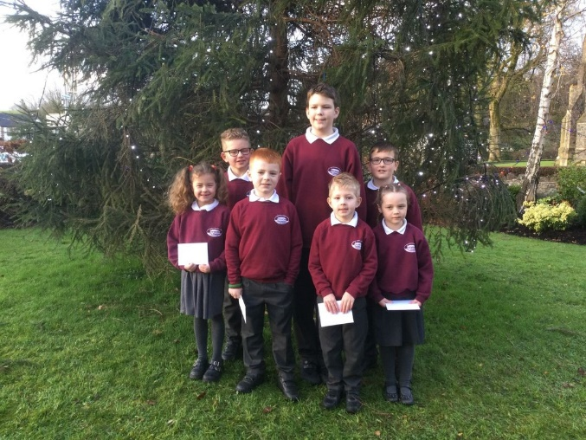
This morning, we took our 7 winners down to Cullybackey to receive their prizes from Cranswick! The children were delighted with their Smyths Toys vouchers. Well done once again to Ewan, Jack, John, Tommy, Olivia, Isaac and Brooke. We also want to thank Cranswick for providing every child in school with a tube of sweets this Christmas.

Thank you!
Thank you so much to all our families for your support and encouragement over the course of term 1 and it has been a joy for me to get to know your children since half term. On behalf of everyone here in The Diamond, thank you for all the lovely cards, treats and gifts we have received. We really appreciate your thoughtfulness and want to wish you a happy Christmas and blessed new year.

Many thanks,

L Boyd

